Week 0:
ROLL NO:241801278
NAME:Sudiksha S
Q1)Write an algorithm and draw a flowchart to calculate the area and perimeter of a square
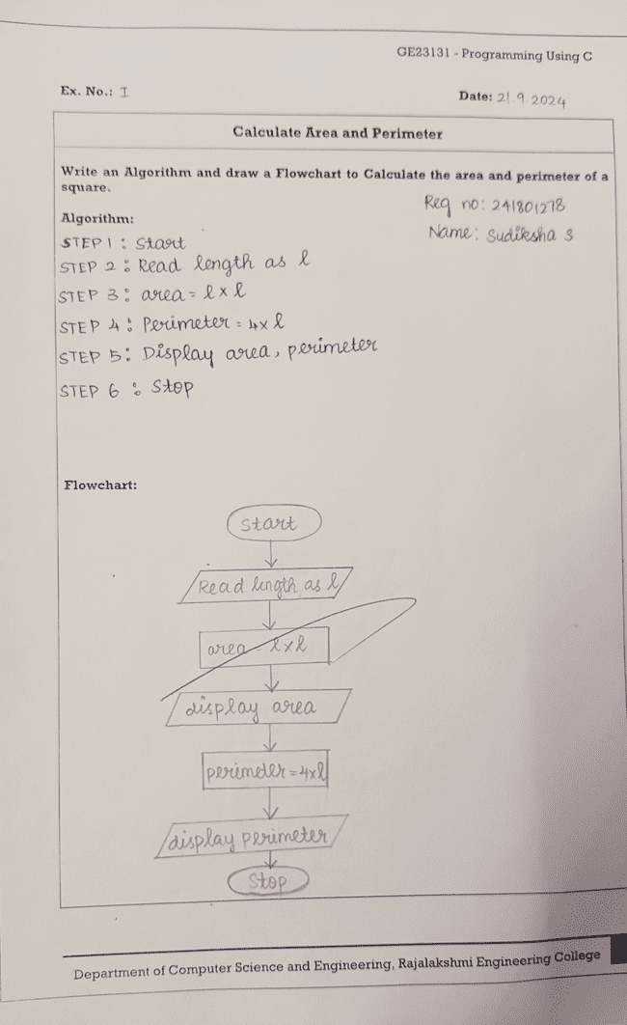
Q2)Write an algorithm and draw a flowchart to convert the given days into years and months
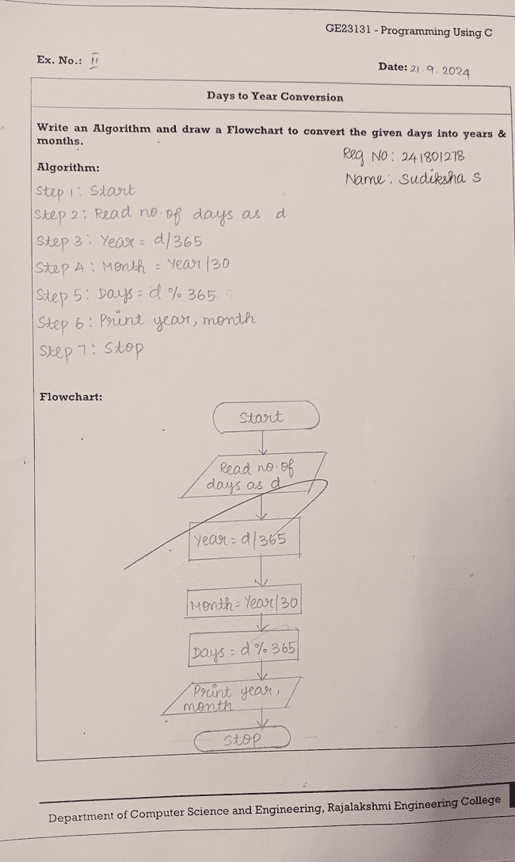
Q3)Write an algorithm and draw a flowchart to check whether the given number is prime or not
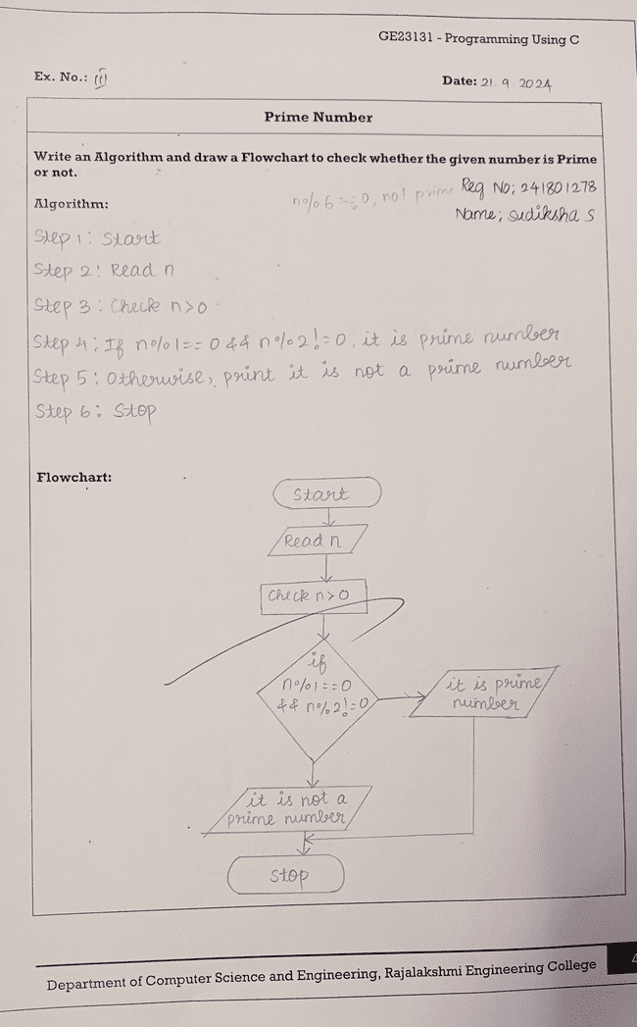
Q4)Write an algorithm and draw a flowchart to check whether the given year is leap year or not
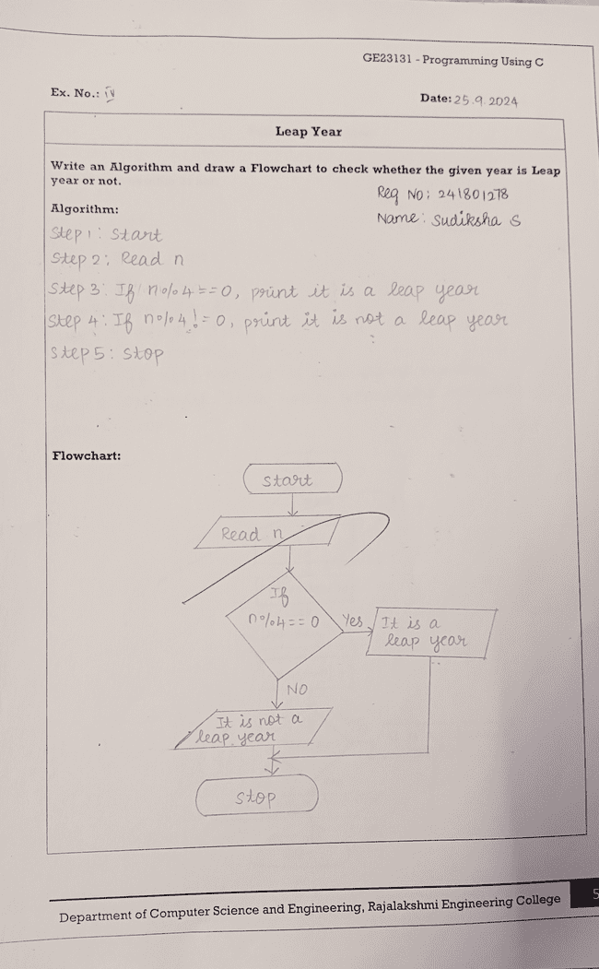
Q5)Write an algorithm and draw a flowchart to check whether the given number is palindrome or not
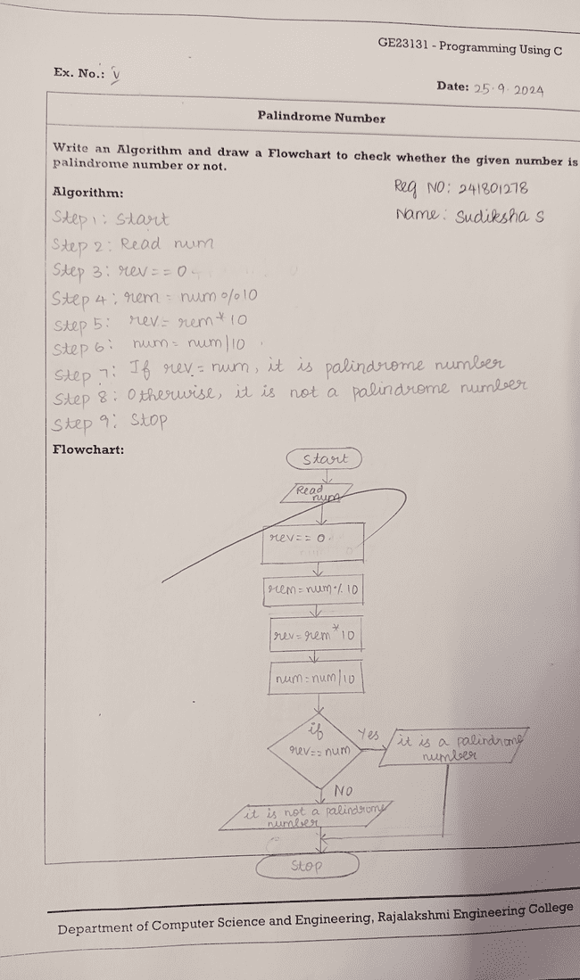
Q6)Write an algorithm and draw a flowchart to calculate the sum of digits in the given number
